

**INT-404 Artificial Intelligence**

Final Report

on

Fight COVID {Chat bot}

**Submitted By**

|  |  |  |
| --- | --- | --- |
| **Roll No** | **Name** | **Reg No** |
| 05 | Dushyanth Desu | 11806172 |
| 14 | I Rohan Swapneel | 11801847 |

**Submitted To :** Sagar Pande Sir

**Abstract**

We have created a chat bot and its name is Fight COVID. The name itself tells that out project is about Coronavirus. This chat bot contains all the information regarding COVID-19. The users can ask anything related to corona virus like what it is, symptoms, safety measures and number of positive cases, deaths etc in India and all over the world. This chat bot accurately answers each and every question related to coronavirus. The world is fighting with coronavirus and there is lot of human and economic crisis all over the world. It is our responsibility to know everything about this virus and keep ourselves safe. So we decided to develop an application which will make easier for people to know everything about this deadly virus and fight against it.

**Related work**

We have decided to make a chat bot but it became very difficult for us to answer the question “ What is the work of our chat bot? ” and the situation at that time motivated us to choose the topic “ coronavirus ”. We initially started finding about the necessary concepts we need to learn before implementing the code. This chat bot is mainly built using keras and natural language processing (NLP). Initially our work included learning about tokenization, lemmatization, keras, NLP, GUI and other tools, libraries and concepts which are required for this project. We learned from different websites like towards data science, data flair, tech with tim and some online videos, books etc to advance in these concepts before starting our project and we also continued this learning process during the implementation of our project/code to give the best output.

**Implementation**

After knowing something and becoming familiar with the concepts, we divided our project into different modules and assigned the modules equally to each other. Our work was to successfully complete the modules assigned to each other on time. With regular discussions about the code and other things, we both completed all the modules and finally combined them into a major project.

**Important libraries used**

The important libraries, modules and packages used in this project are nltk, keras, tensor flow, pickle, numpy and tkinter for GUI programming.

The **Natural Language Toolkit (NLTK)** is an open source python suite of libraries for Natural Language Processing. It supports classification, tokenization, stemming, lemmatization, tagging, parsing and semantic reasoning functionalities. In nltk we used word_tokenize() method to tokenize the intents and WordNetLemmatizer() is used for lemmatization of the tokenized words.

**Keras** Sequential API is used to to build a deep neural network that has 3 layers.

**JSON** (JavaScript Object Notation) module is used to parse, read and write JSON in python. The intents which are used in this project which contains the patterns and the responses of the data are stored in a file in json format.

The **pickle** module implements binary protocols for serializing and de-serializing a python object structure. Pickling is the process where by a python object hierarchy is converted into a byte stream and unpickling is the inverse of this operation. After lemmatizing the tokenized words, the bag of words which creates the python objects are stored in a pickle file.

**Team responsibilities**

Our team consists of two members. Our responsibility was to complete the project on time.

|  |  |
| --- | --- |
| Dushyanth Desu | I Rohan Swapneel |
| Written some part of the intent file | Completed another part of the intent file |
| Few lines of main code | Few lines of main code |
| GUI programming | GUI programming |
| Progress report | Final report |

**Screenshots of the project**

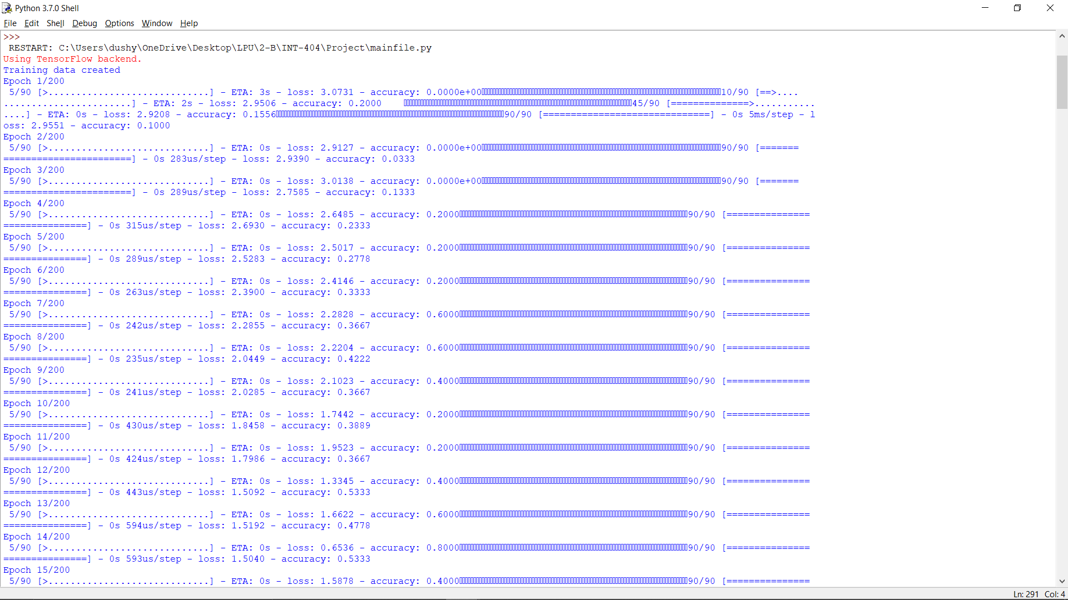

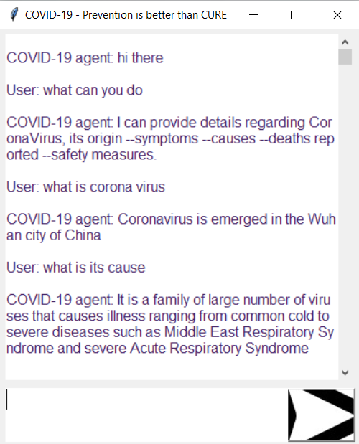

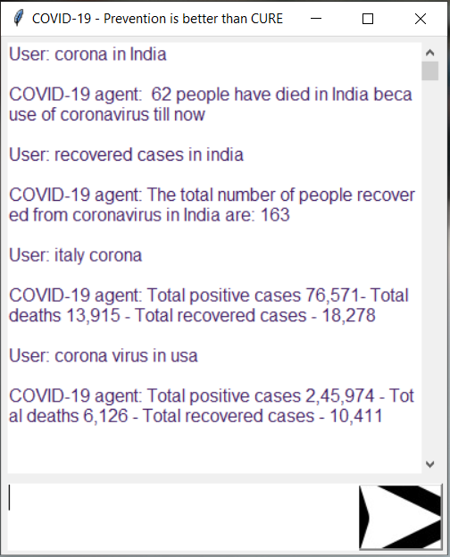

**References**

<https://www.nltk.org/>

<https://techwithtim.net/tutorials/ai-chatbot/part-1/>

<https://data-flair.training/blogs/python-chatbot->

<https://towardsdatascience.com/how-to-create-a-chatbot-with-python-deep-learning-in-less-than-an-hour-56a063bdfc44>